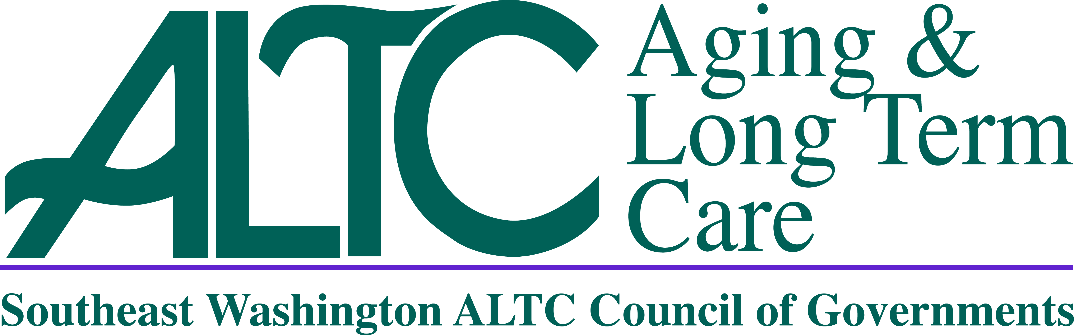
Governing Board of Southeast Washington Aging and Long Term Care
Council of Governments
June 2, 2022 at 10:30a.m.
REGULAR MEETING AGENDA
NOTICE:
This is a hybrid In-Person/Zoom Meeting
Instructions for Calling In:
You are not required to state your name to attend this meeting
Dial This Number: 1 253 215 8782
Passcode: 021066
- Call To Order Commissioner Chris Seubert, Chair
- Roll Call Commissioner Chris Seubert, Chair
- Additions/Changes to Agenda Commissioner Chris Seubert, Chair
- Approval of Previous Meeting Minutes (Action Required) Commissioner Chris Seubert, Chair
  - April 7, 2022

- Director’s Report Lori Brown, SE WA ALTC Director
- Financial Report Lori Brown, SE WA ALTC Director
- Resolution’s (Action Required) Lori Brown, SE WA ALTC Director

Resolution | Purpose
2022-07 | Cancelation of Unclaimed Warrants
2022-08 | Health Reimbursement Voluntary Employees’ Beneficiary Association Trust

- Claims /Payroll Warrants (Action Required) Lori Brown, SE WA ALTC Director

Warrant | Date | Warrant Number | Amount
Claim | 4.15.22 | 16426 - 16531 | $289,693.89
Claim | 4.29.22 | 16532 - 16582 | $631,626.92
Claim | 5.2.22 | 16583- 16593 | $38,720.81
Claim | 5.13.22 | 16594 - 16694 | $241,751.17
Claim | 5.31.22 | 16695 - 16746 | $613,513.68
Claim | 6.1.22 | 16747 - 16757 | $38,740.81
Claims Total |  |  | $1,854,047.28
Payroll | 4.8.22 | 220408001 - 220408130 | $347,190.31
Payroll | 4.25.22 | 220425001 - 220425129 | $356,142.13
Payroll | 5.10.22 | 220510001 - 220510127 | $340,987.60
Payroll | 5.25.22 | 220525001 - 220525131 | $347,370.76
Payroll Total |  |  | $1,391,690.80
Grand Total of Claims/  Payroll Warrants |  |  | $3,245,738.08

- Public Comment All
- Next In Person Meeting Discussion Commissioner Chris Seubert, Chair
  - Date/Time/Location/Agenda Items
- Adjourn Commissioner Chris Seubert, Chair

