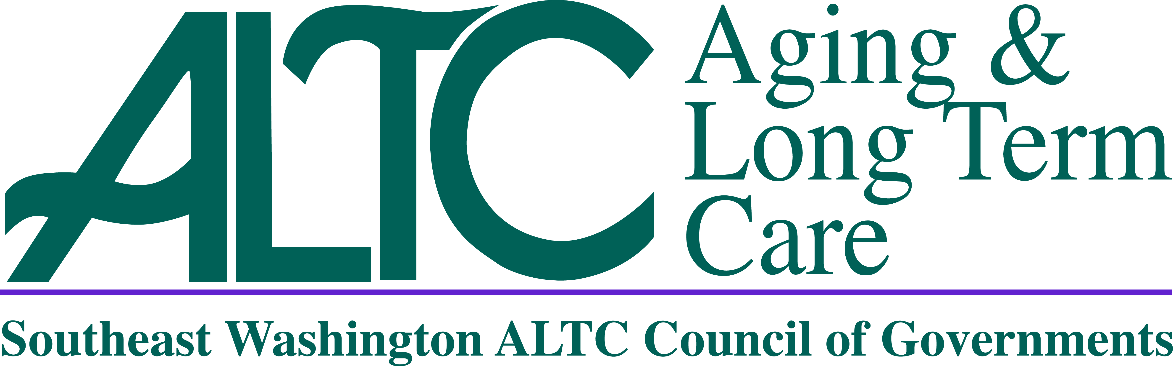
SE WA ALTC

Advisory Council Meeting Agenda

June 17th, 2022

10:00am

Per the State of Emergency Orders, Signed by Governor Inslee, Proclamation 20-28,
This is a Virtual or Telephonic Meeting Only. There is No In-Person Component for this Meeting.
Dial in Number: 253 215 8782
Meeting ID: 860 6150 7127
Passcode: 881568

10:00am Call To Order – Regina Speer, Chair

Roll Call

Additions/Changes to Agenda

10:05 – 10:10am New Business
- Approval of Minutes, April 15, 2022 – Regina Speer, Chair
- Star C Update – Corrie Blythe, SE WA ALTC Assistant Director

10:10 – 10:45am

SE WA ALTC Management Report – Lori Brown, SE WA ALTC Director
- SCOA Report - Kathy Medford, SCOA Representative
- Advisory Council Local Meeting Reports – Local County Chair or Designee

10:45 – 11:45

11:55 Good of the Order/ Next Advisory Meeting (2 mins maximum per speaker)

Next Advisory Council Meeting Date/Location

August 19, 2021

10:00am

Via Zoom

12:00pm Adjournment

Director’s Report
**Topics that may be included but limited to:
  - Council of Governments (COG) Update
  - ALTC Staffing/Programs
  - Federal/State Legislative Update
PLEASE NOTE: The 501c3 Funds Report, SCOA Report and Director’s Report were provided in the agenda packet and will be incorporated into the minutes of today’s meeting as attachments.

