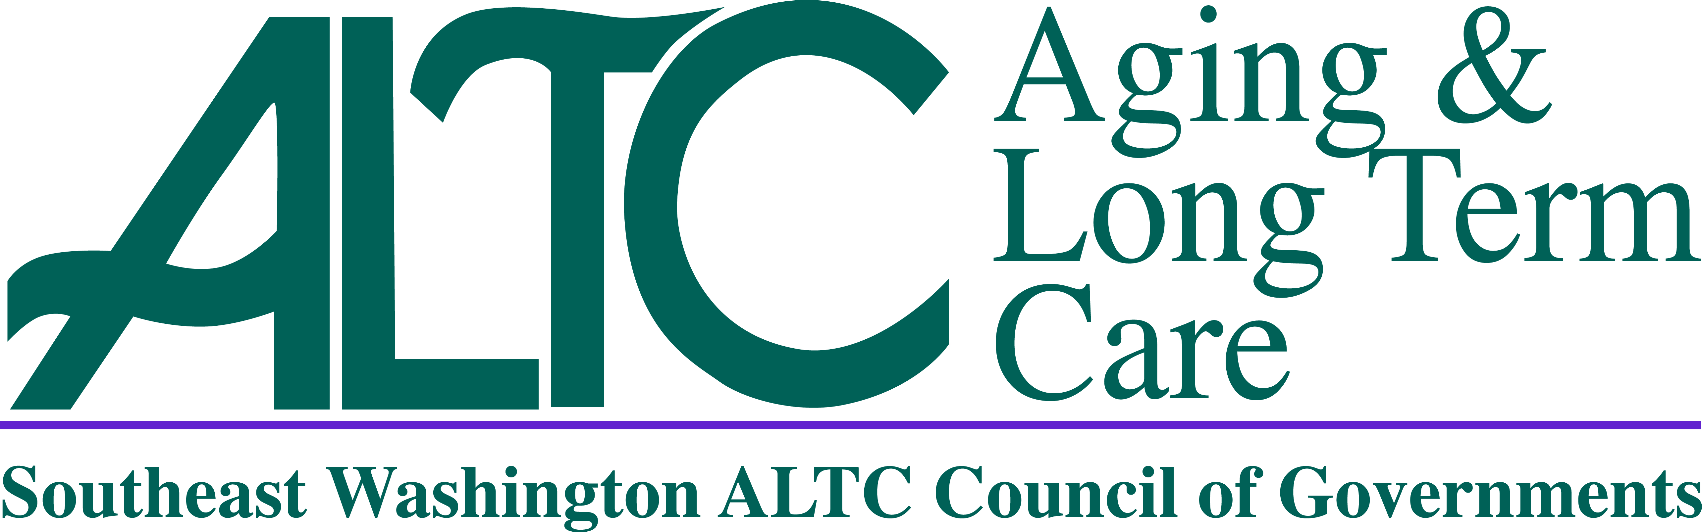
SE WA ALTC

Advisory Council Meeting Agenda

April 15, 2022

10:00am

Per the State of Emergency Orders, Signed by Governor Inslee, Proclamation 20-28,
This is a Virtual or Telephonic Meeting Only. There is No In-Person Component for this Meeting.
Dial in Number: 253 215 8782
Meeting ID: 850 5174 5991
Passcode: 355730

10:00am Call To Order – Regina Speer, Chair

Roll Call

Additions/Changes to Agenda

10:05am New Business
- Approval of Minutes, February 25, 2022 – Regina Speer, Chair

10:10 – 10:55am
- Older Americans Act (OAA) Program Presentation – Coming Back from COVID – Nathan Hart, Program Specialist

11:00 – 11:45am

SE WA ALTC Management Report – Lori Brown, SE WA ALTC Director
- SCOA Report - Kathy Medford, SCOA Representative
- Advisory Council Local Meeting Reports – Local County Chair or Designee

11:55 Good of the Order/ Next Advisory Meeting (2 mins maximum per speaker)

Next Advisory Council Meeting Date/Location

June 17, 2021

10:00am

Via Zoom

12:00pm Adjournment

Presenter Nathan Hart’s Background
Nathan monitors and supports most OAA contractors including our Nutrition contracts.

Nathan started at ALTC in January 2020. Before that he worked at ESD 105 in Yakima, helping administer and monitor a Head Start contract.

Director’s Report
**Topics that may be included but limited to:
  - Council of Governments (COG) Update
  - ALTC Staffing/Programs
  - Federal/State Legislative Update
PLEASE NOTE: The 501c3 Funds Report, SCOA Report and Director’s Report were provided in the agenda packet and will be incorporated into the minutes of today’s meeting as attachments.

