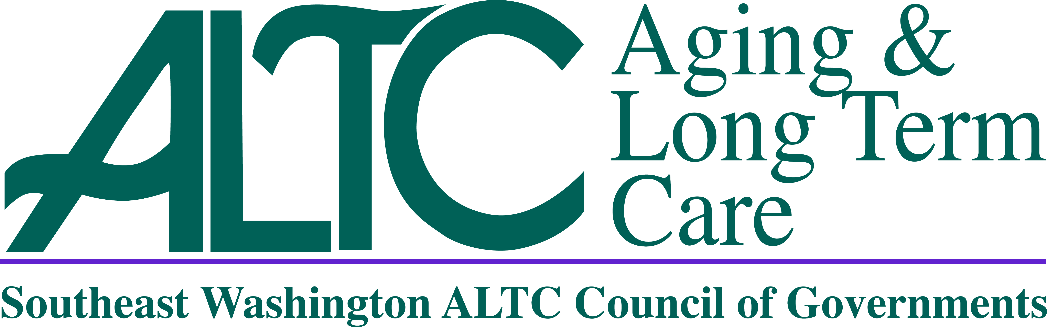

**Governing Board of Southeast Washington Aging and Long Term Care**

**Council of Governments**

**February 3, 2022 at 10:30a.m.**

**REGULAR MEETING AGENDA**

**NOTICE:**

Per the State of Emergency Orders, Signed by Governor Inslee, Proclamation 20-28,

This is a Telephonic Meeting Only. There is No In-Person Component for this Meeting

Instructions for Calling In:

You are not required to state your name to attend this meeting

**Dial This Number:**  1 (253) 215 8782

**Passcode:** 880540

1. Call To Order Commissioner Chris Seubert, Chair
2. Roll Call Commissioner Chris Seubert, Chair
3. Additions/Changes to Agenda Commissioner Chris Seubert, Chair
4. Approval of Previous Meeting Minutes *(Action Required)*  Commissioner Chris Seubert, Chair
   * December 2, 2021
5. Director’s Report Lori Brown, SE WA ALTC Director
6. Financial Report Lori Brown, SE WA ALTC Director
7. Resolutions *(Action Required)*  Lori Brown, SE WA ALTC Director



1. Claims /Payroll Warrants *(Action Required)*  Lori Brown, SE WA ALTC Director



1. Public Comment All
2. Next In Person Meeting Discussion Commissioner Chris Seubert, Chair
   * Date/Time/Location/Agenda Items
3. Adjourn Commissioner Chris Seubert, Chair