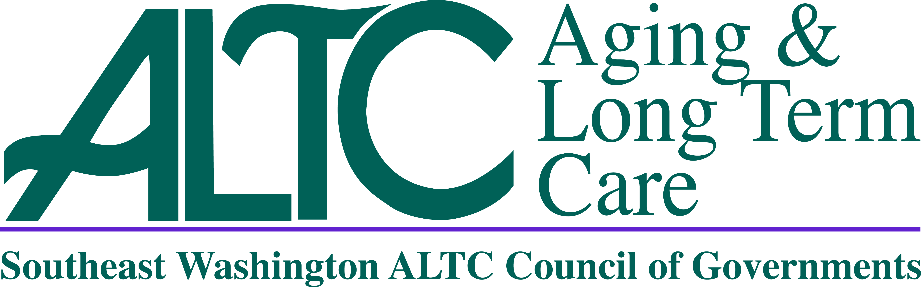
SE WA ALTC

Advisory Council Meeting Agenda

November 19, 2021

10:00am

Per the State of Emergency Orders, Signed by Governor Inslee, Proclamation 20-28,
This is a Virtual or Telephonic Meeting Only. There is No In-Person Component for this Meeting.
Dial in Number: 253 215 8782
Meeting ID: 826 3721 1528
Passcode: 484760

10:00am Call To Order – Regina Speer, Chair

Roll Call
Additional Attendees

Additions/Changes to Agenda

10:05am New Business
Approval of Minutes, August 20, 2021 – Regina Speer, Chair

SE WA ALTC Management Report – Lori Brown, SE WA ALTC Director

11:00 – 11:30am
Family Caregiving Support Services, Tailored Support for Older Adults (TSOA) and Medicaid Alterative Care (MAC) Programs – LeAnne Turnbull – Regional LPC

11:30 – 11:45am
Advisory Council Local Meeting Reports – Local County Chair or Designee

11:45 – 12:00pm

Good of the Order/ Next Advisory Meeting (2 mins maximum per speaker)

Next Advisory Council Meeting Date/Location

February 18, 2022 at 10:00am
- Location TBD

12:00pm Adjournment

LeAnne Turnbull Bio
LeAnne has been with ALTC since March of 2012 and started as a Case Manager and was promoted to Lead and then to Local Program Coordinator.
LeAnne was also the person who authorized the very first service for a TSOA client in the State of Washington!

Director’s Report
**Topics that may be included but limited to:
  - Council of Governments (COG) Update
  - ALTC Staffing/Programs
  - Federal/State Legislative Update

PLEASE NOTE: The 501c3 Funds Report, SCOA Report and Director’s Report were provided in the agenda packet and will be incorporated into the minutes of today’s meeting as attachments.

