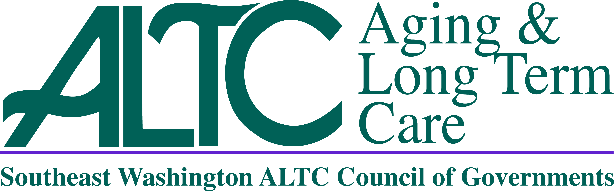
SE WA ALTC

Advisory Council Meeting Agenda

February 19, 2021

10:00am

Per the State of Emergency Orders, Signed by Governor Inslee, Proclamation 20-28,
This is a Virtual or Telephonic Meeting Only. There is No In-Person Component for this Meeting.

10:00am Call To Order – Regina Speer, Chair

Roll Call

Additions/Changes to Agenda

10:10am New Business
- Approval of Minutes, November 20, 2020 – Regina Speer, Chair

SE WA ALTC Management Report – Lori Brown, SE WA ALTC Director
**Topics that may be included but limited to:
  - Council of Governments (COG) Update
  - ALTC Staffing/Programs
  - Federal/State Legislative Update

10:30am – 11:30am Department of Health Presentation
- Update on COVID and Vaccinations – Guest Speaker

11:30am Good of the Order (2 mins maximum per speaker)

11:55am Next Advisory Council Meeting Date/Location

April 16, 2021

10:00am

Location (TBD)
12:00pm ADJOURNMENT
PLEASE NOTE: The 501c3 Funds Report, SCOA Report and Director’s Report were provided in the agenda packet and will be incorporated into the minutes of today’s meeting as attachments

