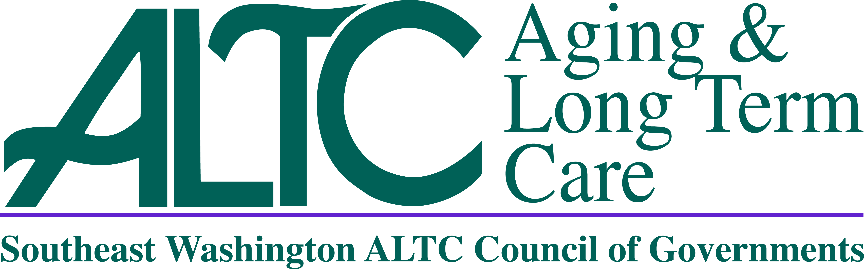
Southeast Washington Aging and Long Term Care
Council of Governments
Governing Board Meeting
September 7, 2017
Greater Columbia Behavioral Health
101 N Edison, Kennewick, WA
10:30 a.m.
AGENDA

- Welcome & Introductions Commissioner Robert Johnson, Chair
- Additional Agenda Items Commissioner Robert Johnson, Chair
- Review and Approval of July 6, 2017 Meeting Minutes Commissioner Robert Johnson, Chair
- Director’s Report Lori Brown, SE WA ALTC Director
- Report:June & July 2017 Revenue & Expenditure/Balance Sheet Lori Brown, SE WA ALTC Director

- ALTCCOG 2017-66; 2017 SLRNW (NUTR), Mod No 01 Lori Brown, SE WA ALTC
- Director

Nutrition Services in Benton/Franklin Counties - $567,336 (Increase $15,000)

- ALTCCOG 2017-67; 2017 PFP (NUTR), Mod No 02 Lori Brown, SE WA ALTC
- Director

Nutrition Services in Yakima County - $767,341 (Increase $70,000)

- ALTCCOG 2017-68; DSHS #1769-93480 State Federal, Lori Brown, SE WA ALTC
- Director
Amendment No. 01; $9,839,256 (Increase $2,164,374)

Southeast Washington Aging and Long Term Care
Council of Governments
Governing Board Meeting
September 7, 2017
Greater Columbia Behavioral Health
101 N Edison, Kennewick, WA
10:30 a.m.
AGENDA (continued)

- Claims /Payroll Warrants Lori Brown, SE WA ALTC Director
Warrants (Claims & Payroll) | Amount
Claims Clearing Warrant | $352,525.69
Claims Clearing Warrant | $309,254.19
Claims Clearing Warrant | $33,261.20
Claims Clearing Warrant | $186,653.81
Claims Clearing Warrant | $352,202.69
Claims Clearing Warrant | $33,261.20
Subtotal of Claims Warrants | $1,267,158.78
Payroll Clearing Warrant | $274,886.07
Payroll Clearing Warrant | $280,931.22
Payroll Clearing Warrant | $284,404.65
Payroll Clearing Warrant | $286,522.72
Payroll Clearing Warrant | $280,775.15
Subtotal of Payroll Warrants | $1,407,519.81
Grand Total of All Warrants | $2,674,678.59

- Public Comment Period All
- Next Meeting Date/Time/Location/Agenda Items Commissioner Robert Johnson, Chair
- Adjourn Commissioner Robert Johnson, Chair

